**-- 19/08/24 task –**

**-- WITH USE OF INNER JOIN PRINT THE ONLY MATH SUBJECT STUDENT NAME AND MARKS --**

**With new table marks**

SELECT marks.*, students.NAME, Subjects.subject_name

FROM marks

INNER JOIN Subjects ON marks.subject_id = Subjects.subject_id

INNER JOIN students ON marks.student_id = students.student_id

WHERE subjects.subject_name = 'math'

order by marks.marks_id;

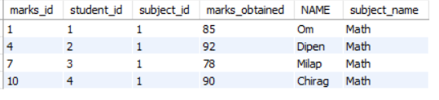

**-- WITH USE OF INNER JOIN PRINT THE ONLY MATH SUBJECT STUDENT NAME AND MARKS --**

**With new table marks1**

select students.student_id, students.name, marks1.math, marks1.attempts

from students

inner join marks1 on marks1.student_id =students.student_id

order by students.student_id;

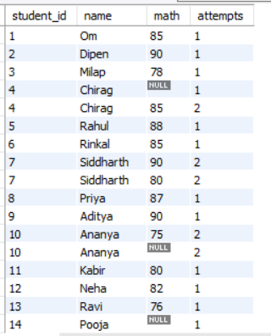

**-- WITH USE OF INNER JOIN PRINT THE ONLY ENGLISH SUBJECT STUDENT NAME AND MARKS --**

SELECT marks.*, students.NAME, Subjects.subject_name

FROM marks

INNER JOIN Subjects ON marks.subject_id = Subjects.subject_id

INNER JOIN students ON marks.student_id = students.student_id

WHERE subjects.subject_name = 'English'

order by marks.marks_id;

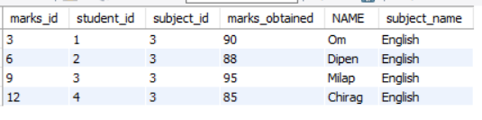

**-- WITH USE OF INNER JOIN PRINT THE ONLY ENGLISH SUBJECT STUDENT NAME AND MARKS --**

**With new table marks1**

select students.student_id, students.name, marks1.english, marks1.attempts

from students

inner join marks1 on marks1.student_id =students.student_id

order by students.student_id;

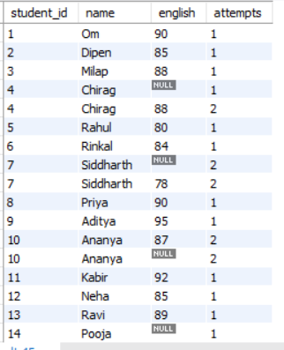

**-- ALL STUDENT RESULT –**

select students.student_id, students.name, marks1.*

from students

inner join marks1 on marks1.student_id =students.student_id

order by students.student_id;

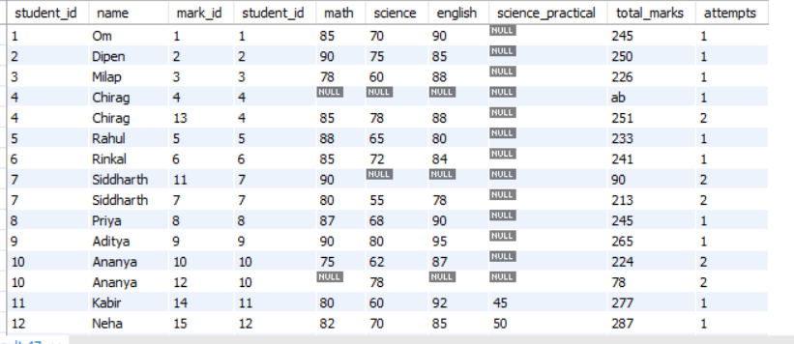

**-- 1 student all marks --**

select students.student_id, students.name, marks1.*

from students

inner join marks1 on marks1.student_id = students.student_id

where students.student_id = 1;



**-- HIGHEST MARKS of one students from math subject –**

select students.student_id, students.name, marks1.math AS max_math_mark

from students

inner join marks1 on marks1.student_id = students.student_id

order by marks1.math desc

limit 1;



**-- LOWEST MARKS of one students from math subject --**

select students.student_id, students.name, marks1.math AS min_math_mark

from students

inner join marks1 on marks1.student_id = students.student_id

WHERE marks1.math IS NOT NULL

order by marks1.math asc

limit 1;



**-- class detail --**

select * from class_details;

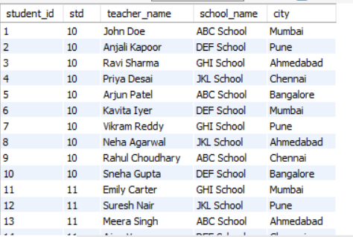

**-- exams detail --**

select * from exams;

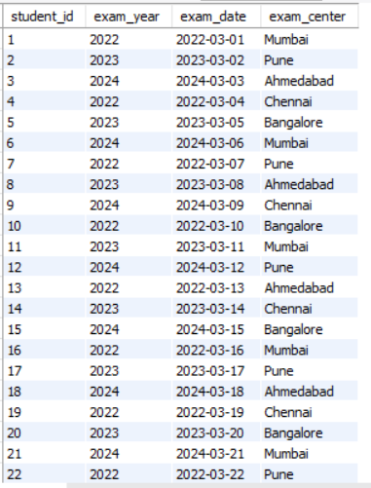

**-- Ab of students--**

select students.student_id, students.name, marks1.*

from students

inner join marks1 on marks1.student_id = students.student_id

WHERE marks1.total_marks = 'ab'

order by students.student_id;

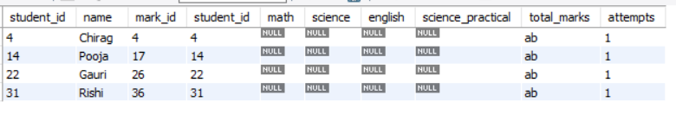

**-- Gender of students--**

select * from students;

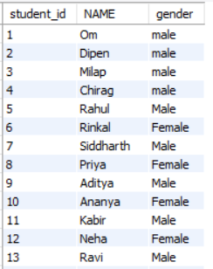

**-- SCIENCE SUBJEC FINAL RESULT--**

select students.student_id, students.name, marks1.science, marks1.science_practical ,(marks1.science + COALESCE(marks1.science_practical, '0')) AS total_science_marks

from students

inner join marks1 on marks1.student_id = students.student_id

order by students.student_id;

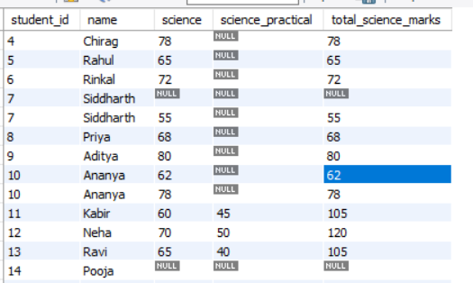

**-- CLASS DETAILS--**

SELECT * FROM class_details;

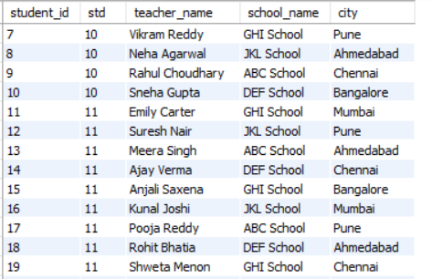

**-- Std details--**

select students.student_id, students.name, class_details.std

from students

inner join class_details on class_details.student_id = students.student_id

order by students.student_id;

